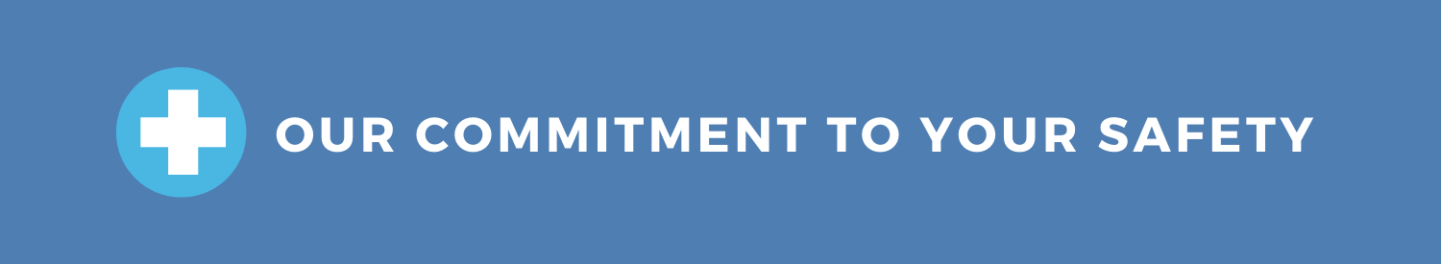

OFFICE TEMPORARILY CLOSED

We have decided to temporarily close this office to ensure the health and safety of our patients, team members and community. Please be assured that this temporary closure is a proactive measure to support our commitment to provide best-in-class patient care during the current Coronavirus (COVID-19) pandemic.
We expect the office to re-open on DATE. Our team will monitor CDC recommendations for guidance and will re-evaluate the re-opening date accordingly.
If you have a dental emergency or require immediate treatment, please call PHONE NUMBER and we will do our best to help.
If you would like to schedule a new appointment or reschedule an existing appointment, please call PHONE NUMBER.
We take great pride in serving our community. Thank you for choosing us as your family’s dental provider.
******
FOR SAFTEY GUIDELINES DURING THE CORONAVIRUS (COVID-19) PANDEMIC,
PLEASE VISIT: www.cdc.gov

