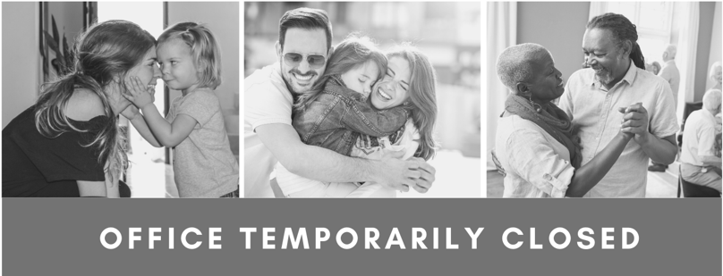

Our team has decided to temporarily close this office to ensure the health and safety of our patients, team members and communities during the current Coronavirus (COVID-19) pandemic. We currently plan to reopen the office on April 15th, 2020.
If you need treatment for a dental emergency and/or if you are in pain, our team is here to help and can provide treatment at another office in the area. Please call the following phone number and we will be happy to help you schedule an appointment for essential treatment. All appointments should be scheduled in advance.
Local office that remains open for essential treatment:

Office name: ____________________________________________________________________

Office address: ___________________________________________________________________

Phone number: __________________________________________________________________

We are currently scheduling appointment for any non-essential treatment, including hygiene appointments, for after April 15th.
The safety of our patients, team members and community are paramount. As the Coronavirus pandemic evolves, we will continue to actively monitor the local situation and follow CDC recommendations.
We are hopeful these proactive changes will contribute to helping our community get past the Coronavirus situation soon. We are committed to serving our community and are here to help.
Thank you for choosing our practice as your family’s dental provider.

