I. Purpose

As the COVID-19 pandemic escalates, increasing testing capacity will further allow dentists to help the overall healthcare community by identifying a wider group of COVID positive patients. It is critical for close collaboration of all healthcare providers to help reduce viral community spread. Screening measures in dental practices will help reduce the surge in traditional testing facilities and help flatten the curve. This standard operating procedure is to provide directions on important actions to follow when performing COVID-19 diagnostic tests.

II. Scope

The following scenarios prompt COVID-19 testing in dental practices:
- All dental practice team members actively working in the practice
- Any patient reporting to the practice who answers “Yes” to any of the following screening protocol questions:
  - Have you traveled internationally in the last 30 days?
  - To your knowledge, have you been in contact with a COVID-19 patient?
  - Are you experiencing any flu-like symptoms?
    - Shortness of breath?
    - Fever?
    - Cough?

II. Procedure

- Triage and Intake:

- Identifying candidates for COVID-19 screening:
  - Dentist working in practice, and/or
  - Primary Care Physician (PCP) identifies patients needing test
  - Clinicians should use their judgement to determine if a patient has signs and symptoms compatible with COVID-19 and whether the patient should be tested, based on established screening protocol above.
- Obtain patient’s consent by having them complete an Intake Form
- Verify patient’s demographics, insurance information and contact number to report results
- Provide patient a copy of the COVID-19 information sheet for educational purposes (to be developed)

- Administer the test:
Must be completed by a doctor until regulations allow other dental professionals the ability to administer.

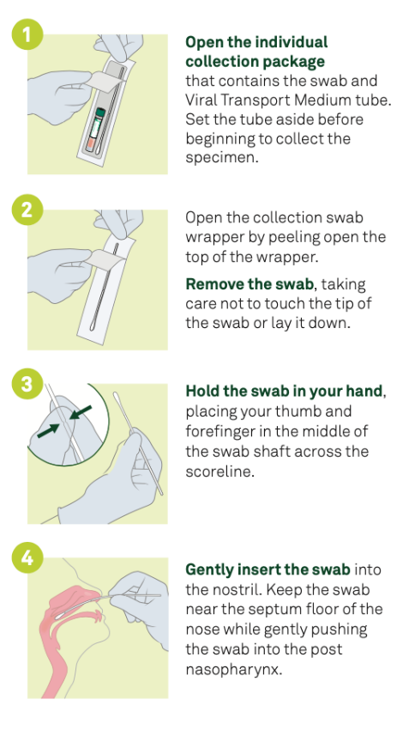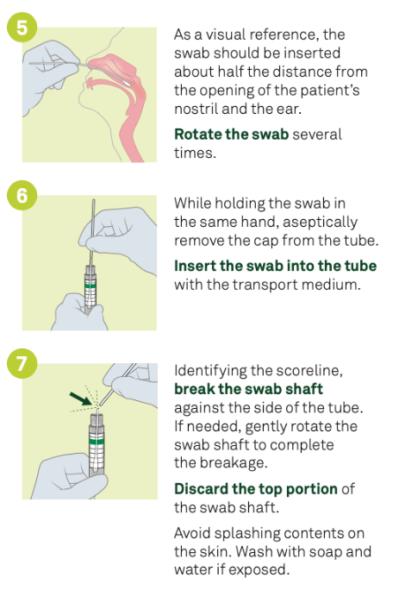

- Specimen handling:

  - After test is completed, to ensure accuracy, have patient confirm name and demographics on sample obtained.
  - Place specimen in designated receptacle for transport to approved laboratory as end of day procedures.
  - Skip step if COVID-19 rapid test is available.

- Patient Instructions:

For Negative test results:
- Provide patient negative test results documentation.
- Proceed with dental treatment.

For Positive test results:
- Inform patient that dental treatment will be postponed until a time when they are well
- Consistent with CDC recommendations, patients are given the following instructions:
CDC Guidance: Steps When Sick (Link)
- Stay home except to get medical care
- Separate yourself from other people and pets in your home
- Monitor your symptoms
- If you develop emergency earning signs for COVID-19 get medical attention immediately, i.e.
  - Trouble breathing
  - Persistent pain or pressure in the chest
  - New confusion or inability to arouse
  - Bluish lips or face
- Reporting: The CDC guidelines require that we report findings for Positive tests with both local and state Health Departments by completing the Novel Coronavirus Case Report Form found here (Link)
  - State Health Departments: https://www.cste.org/page/EpiOnCall
  - Local Health Departments: https://www.naccho.org/membership/lhd-directory

- Send patient specimen to lab for processing:
  - As part of end of day procedures, send patient samples/specimen to approved lab for processing.
  - Document all specimen sent for proper reconciliation.

- Daily, assign team member to call patients to report test results and patient education. (Doctor only as of now)
  - If rapid tests are available, skip step as results are reported within minutes of taking specimen.

III. Billing

  - Claim Submission:
      - Work with your respective billing team to ensure claims are submitted timely.
      - A claim submission includes the services provided to each patient. Each claim detail line identifies the procedure and the date it was delivered to the patient.
        - D9999 – Unspecified dental procedure by report
        - Include narrative that COVID-19 test was administered on site
        - PCPs are allowed to bill for read, interpretation, and therapy

